Digital   
Communications Lab

**Experiment 2**

Basics of BER calculations and channel models

|  |  |
| --- | --- |
| Name | ID |
| Rashad Elsayed Ibrahim Ahmed | 19015660 |
| Mohamed Samy Mohamed | 19016377 |
| Tasneem AbdulSamad | 19015536 |

# Background

The most basic target of the study of digital communications is to understand digital communication systems and how digital information can be conveyed from a source or transmitter to a destination or receiver over a channel. Depending on the communication systems, channels can be wired circuits, wireless channels, satellite channels and so on. The study of digital communications begins by transforming the digital communication system into an equivalent mathematical model, and then attempts to design transmitters and receivers which achieves the target of information transmission over the channel in an efficient manner.Figure 1 shows an example of a digital communication system. The goal of the transmitter and receiver is to deliver the digital data from the source to the sink in the best way possible. There are several ways to define what *best* mean: one of the most common and most important methods to assess the performance of a communication system is the *Bit Error Rate (BER)*.



**Figure 1 An example of a digital communication system**

|  |
| --- |
| **Bit Error Rate (BER):** the rate of error occurrences among an output sequence of bits corresponding to an input sequence of bits. |

An empirical method of computing the BER in a communication system is as follows:

1. Generate a sequence of $N$ bits at the input side
2. Pass the sequence of input bits through the system to receive a corresponding output sequence
3. Count the number of errors in the output sequence by comparing it to the input sequence; call that number of errors $E$
4. The BER is given by $BER=\frac{E}{N}$

In this experiment, we will compute the BER of different digital communication systems. These systems differ in their respective channel models and therefore their corresponding transmitter and receiver designs.

# Experiment

## Part 1 (3 Marks)

In this part, we consider a very simple digital communication system, in which the channel takes as input binary digits $b= \{0,1\}$, and produces the corresponding output according to the following equation.

$$y= \{b with probability 1-p \underline{b} with probability p$$

The channel described above simply flips the input bit with probability $p$ or passes the input bit unchanged with probability $1-p$; this channel is referred to as the *Binary Symmetric Channel (BSC)*. The system is shown in Figure 2. In this system, we assume that the transmitter takes the input bits coming from the source and passes them unchanged to the channel (i.e., the transmitter does nothing). However, we would like to investigate how the receiver can be designed to produce a good BER.



**Figure 2 A digital communication system with a Binary Symmetric Channel**

Your goal in this task is to design the receiver. You know that the channel takes the data, flips it randomly (with probability $p$) and gives you the output. What would the receiver do with that output?  
Think about the following two receivers and say what is the expected performance of these receivers. As a hint to start, these two receivers are not very good.

**Example 1:** the receiver gives a 0 bit as output. This output does not depend at all on what the channel is giving out.

|  |  |
| --- | --- |
| **Questions** | |
| **What is the corresponding BER for that receiver? You do not need to implement it in the m-file to answer.** | *It depends on number of ones "* at transmitter *" which are received from the channel*  BER = $\frac{no of bit"1"}{total no of bits}$ at the transmitter |
| **What is the reason behind the performance of this receiver?** | As the receiver always outputs "0" whatever the input.  "bad receiver "  When the number of ones increases" zeros are less" , BER also increases  "good receiver "  When the number of ones decreases "zeros are most" , BER also decreases |

**Example 2:** the receiver gives random output, i.e., 0s and 1s with a probability of 0.5. Again, this output is not based on what the channel is giving out.

|  |  |
| --- | --- |
| **Questions** | |
| **What is the corresponding BER for that receiver? You do not need to implement it in the m-file to answer.** | 0.5  As the receiver produces 0s and 1s with a probability of 0.5, the BER would probably be 50%. |
| **What is the reason behind the performance of this receiver?** | Due to the random nature of the receiverand it doesn't depend on the output of channel. |

The above two receivers are examples of receivers which clearly would not be considered as good receivers from a BER perspective **(why?).**

-Because these receivers generate outputs independent of the inputs from the channel.

In the following part of the experiment, you would design the best receiver and assess its performance by computing the corresponding BER.

**EXP. *Complete PART 1 in the experiment M-file* Lab1_script.m *and the missing implementation of all included functions. Then answer the following questions:***

|  |  |
| --- | --- |
| **Questions** | |
| **What is the corresponding BER for receivers 1 and 2 above? You do not need to implement the two receivers to answer.** | receiver 1: BER = $\frac{no of bit"1"}{total no of bits}$ at the transmitter.  receiver 2: As the receiver produces 0s and 1s with a probability of 0.5, the BER would probably be 50%. |
| **What is the reason behind the performance of these two receivers?** | Because these receivers generate outputs independent of the inputs from the channel.  receiver 1:output always '0s'  receiver 2: As the receiver produces 0s and 1s with a probability of 0.5, the BER would probably be 50%. |
| **What is the BER of the best receiver?** | 0.1952 |

### Part 1-a (2 Marks)In this part, we study the impact of the BSC channel parameter $p$ on the BER of the digital communication system. Namely, we vary the value of $p$ from 0 to 1, and for each value of $p$ we compute the corresponding BER, we save these values in an array, then, later on in Part 3-a, plot the values of BER versus their corresponding parameter value $p$.

**EXP. *Complete PART 1-a in the experiment M-file* Lab1_script.m*. The final figure containing the required plot will be generated at the end of Part 3-a of the experiment.***

## Part 2 (3 Marks)

In this part, we again consider the system proposed in Figure 2 but we try to improve the transmitter a bit. Namely, the transmitter works as follows: for each input bit $b$, the transmitter generates a set of 5 copies of the bit $b$ which are then passed sequentially through the channel. Note that this behavior leads to the increase in the number of bits being passed through the channel **(is that good or bad?).**

- Sending 5 copies of the same bit result in decreasing the BER but it would be required larger bandwidth.

The system is shown in Figure 3. For this transmitter, the receiver expects to receive a sequence of 5 channel outputs, all corresponding to the same input bit. Therefore, we expect that the receiver can use these outputs for a better decoding performance. In this part, we investigate how to design the best receiver and the corresponding BER performance.



**Figure 3 A digital communication system with a Binary Symmetric Channel and a modified transmitter**

**EXP. *Complete PART 2 in the experiment M-file* Lab1_script.m *and the missing implementation of all included functions. Then answer the following questions:***

|  |  |
| --- | --- |
| **Questions** | |
| **What is the BER of the best receiver?** | **0.0213** |
| **What is the expected (theoretical) BER if the number of repetitions is increase to 10?** | the BER is decreased by increasing the number of bits " number of repetition"  It is expected to decrease by 60%. |
| **What is the cost/downside of using the transmitter in Part 2?** | Increasing the number of bits leads to bandwidth expansion |

### Part 2-a (2 Marks)

Similar to Part 1-a, in this part, we study the impact of the BSC channel parameter $p$ on the BER of the digital communication system in Part 2.

**EXP. *Complete PART 2-a in the experiment M-file* Lab1_script.m*. The final figure containing the required plot will be   
generated at the end of Part 3-a of the experiment.***

## Part 3 (3 Marks)

In part 3, we consider the same system in Part 2. However, the channel in Part 3 generates correlated outputs among the 5 transmitter outputs that correspond to the same input bit. For example, for a 0 input bit to the transmitter and a corresponding five copies of the bit 0, the channel output either generates a set of five 0’s with probability $1-p$ or a set of five 1’s with probability $p$. In this case, we investigate the design of the best receiver and the corresponding BER.

**EXP. *Complete PART 3 in the experiment M-file* Lab1_script.m *and the missing implementation of all included functions. Then answer the following questions:***

|  |  |
| --- | --- |
| **Questions** | |
| **What is the BER of the best receiver?** | **0.1994** |
| **What is the reason behind such a performance?** | As the channel generates correlated outputs, so it doesn't matter the number of copies sent by the transmitter. |

### Part 3-a (2 Marks)

Finally, we study the impact of the BSC channel parameter $p$ on the BER of the digital communication system in Part 3.

**EXP. *Complete PART 3-a in the experiment M-file* Lab1_script.m*. The final figure containing the plots from all three parts can now be generated. Please add the generated plot in the box below.***

|  |
| --- |
|  |

|  |  |
| --- | --- |
| **Questions** | |
| **Which of the three systems have the best performance in terms of BER?** | **Second System** |
| **If the receiver you designed in any of the previous parts attain a BER more than 0.5, how can it be changed to attain a maximum of 0.5 BER?** | First by using uncorrelated channel  Then increasing the number of samples |

## Part 4 (8 Marks)

In this part, we go back to the system considered in Part 2, namely the system with a transmitter which generated a set of 5 repetitions to the input bit. Now, we would like to investigate the effect of changing the number of repetitions on the  
 decoding performance. You need to generate a figure where the x-axis shows the number of repetitions, and the y-axis shows the corresponding BER. In this part, you can consider p = 2.

**EXP. *Write your own code in PART 4 in the experiment M-file* Lab1_script.m*. Your code should generate a figure as described in the discussion above.*** 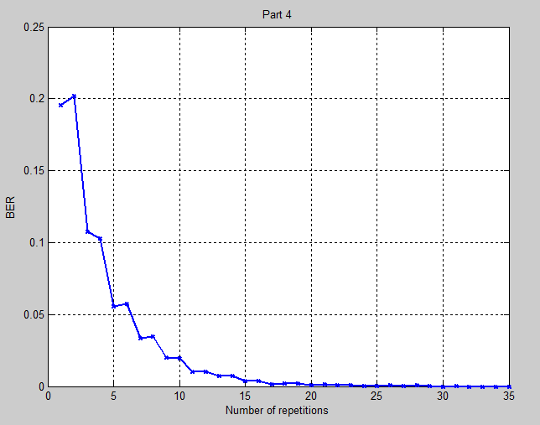

Matlab Code  
  
*1-Generate Bits*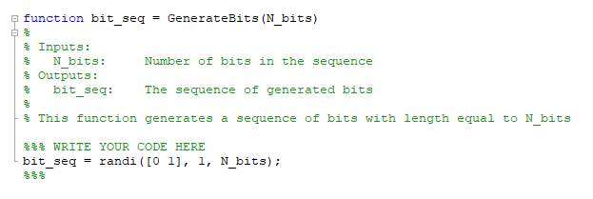

*2-BSC*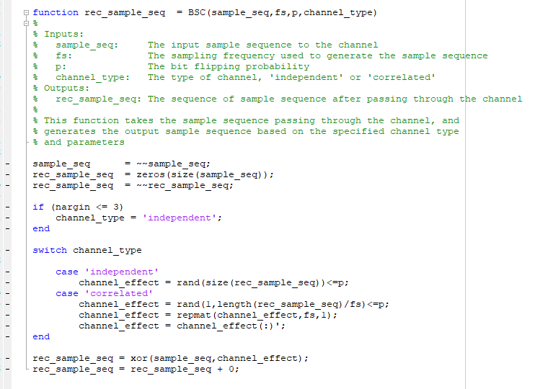

*3-*Compute BER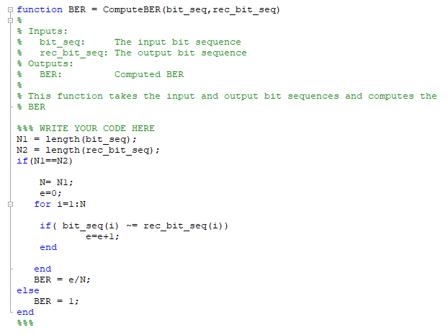

*4-*Generate Samples   
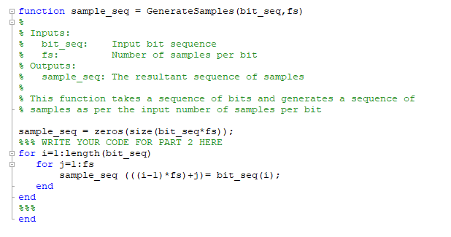

*5-*DecodeBitsFromSamples  
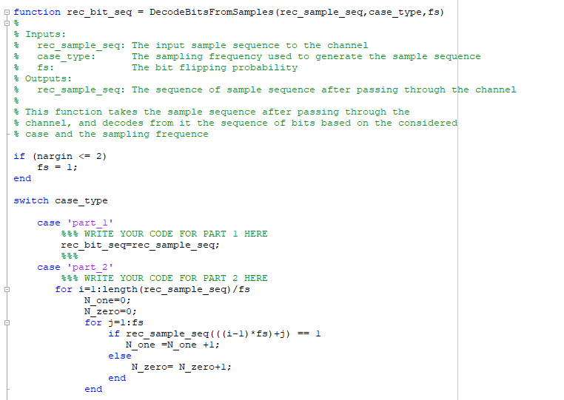

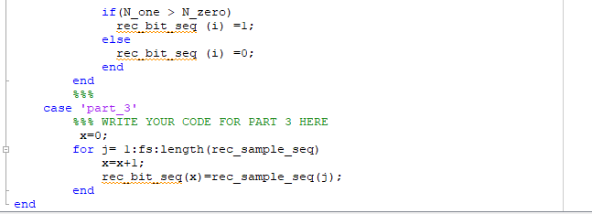

*6- Lab Script*

